# Assignment -1

Dollar Shave Club's

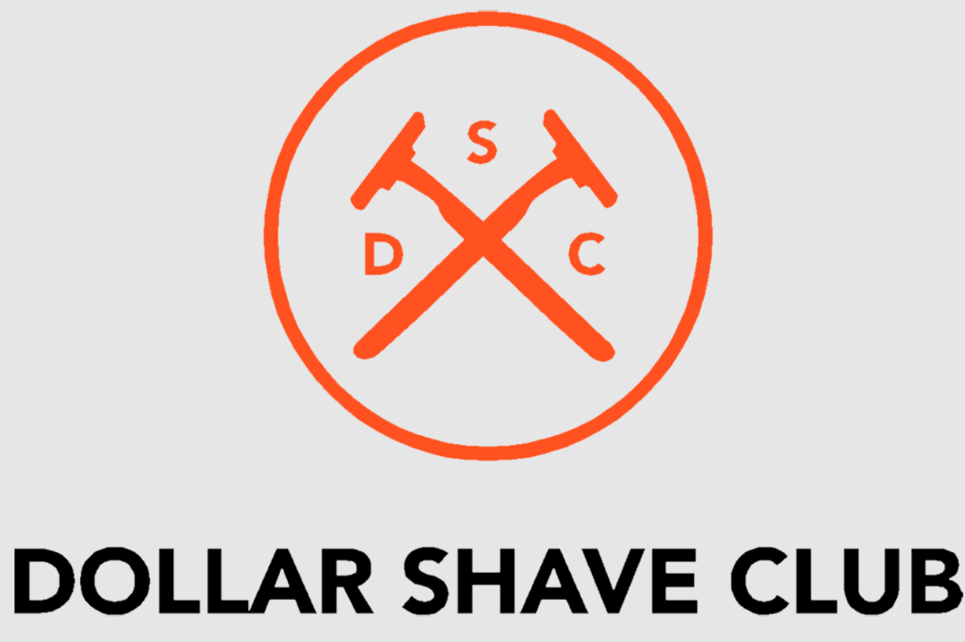

1. *Disruptive Marketing:* Dollar Shave Club gained attention through their viral marketing videos, showcasing humor and personality. Implementing creative and unconventional marketing strategies can help differentiate your brand.

2. *Subscription Model:* Their subscription-based business model ensured recurring revenue and customer loyalty. Consider offering subscription options to create a steady income stream and maintain customer engagement.

3. *Customer-Centric Approach:* Dollar Shave Club prioritized customer experience by offering convenience, quality products, and excellent service. Focus on understanding and meeting your customers' needs to build lasting relationships.

4. *Product Innovation:* Continuously innovate your product offerings to stay competitive and appeal to evolving consumer preferences. Dollar Shave Club introduced new products beyond razors, expanding their market reach.

5. *Brand Identity:* Establish a strong brand identity that resonates with your target audience. Dollar Shave Club's brand persona was relatable and memorable, contributing to their rapid growth.